Gizmoball: Weekly Progress Document (Week 6)

CS308 Group MW1

**New issues:**

* Tidying up of local projects (deleting unnecessary ones)
* Merging of git branches and resolving conflicts
* Merging of prototypes to one project
* Decide on how to handle switch between Build Mode and Play Mode (what class)
* Should absorbers only absorb from top line (if an absorber is not at bottom of board)?

**Ongoing issues:**

* Flipper implementation. Need to rethink design completely apart from static draw
* Handle rotation of gizmos (Triangles and Flippers) and how to delete and repaint a gizmo as rotated

**Resolved issues:**

* Communication between group members (Group)
* Submitted Preliminary release (Group)
* JUnit Testing Strategy document complete (TM, CR)
* Validation Testing Strategy complete (TS)
* Redraw class diagram (DTP)
* 3/4 Prototypes completed to a high standard (Group)
* Completed Updated Gantt chart (GC)
* Update class descriptions document with classes changed and reasons (DTP)
* Implementation of Absorber class for main project and prototype (CR)

**Goals for upcoming week:**

* Design flipper rotation, redrawing and collisions. Get good progress on implementing (TM, CR, GC)
* Update master branch by merging other branches in and solving conflicts (DTP)
* Choose what parts of prototypes to focus on for main project (DTP)
* Merge prototype implementation and have one main project that the group can start working on that will include all features from PR Prototypes (DTP)
* Fix bugs and design problems that will come up because of the merges (Group)
* Start creating test classes for testing objects (gizmos) in Model (TS)

**Git repository history:**

* Commits from today on the several branches:
  + David branch (David-dev this week):

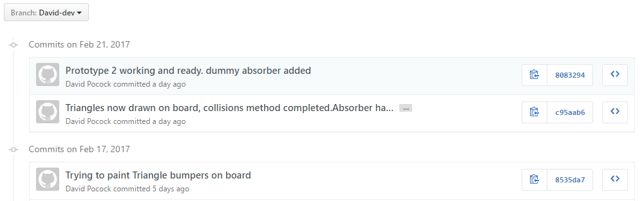

* Greig branch:

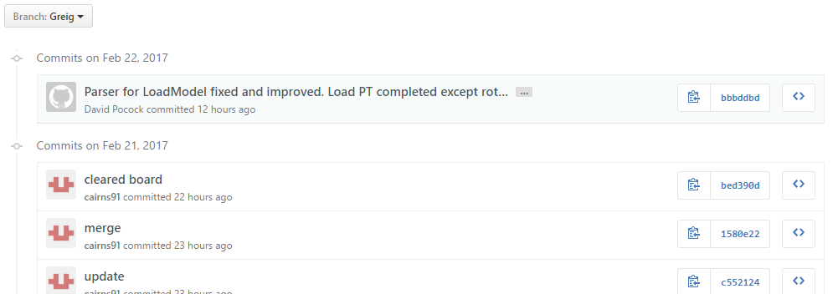

* Chris branch:

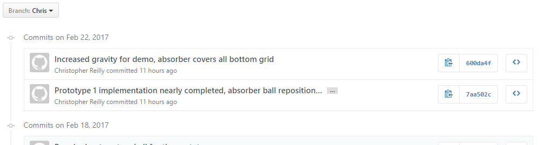

* Thomas branch:

